# ADK PYTHON PRACTICAL ROLL NO.05

**EXPERIMENT NO.1A**

**AIM:*- WRITE THE PROGRAM FOR THE FOLLOWING.(TO FIND NAME AND AGE)***

**A]**CREATE A PROGRAM THAT ASKS THE USER TO ENTER THEIR NAME AND THEIR AGE.PRINT OUT A MESSAGE ADDRESSED TO THEM THAT TELLS THE YEAR THAT WILL TURN 100 YEARS OLD.

**CODE:**

**name = input(“Enter your name:”)**

**Current_age = int (input (“Enter your age:”))**

**new_age = 2022 + (100 – current_age)**

**print(new_age)**

**OUTPUT**:

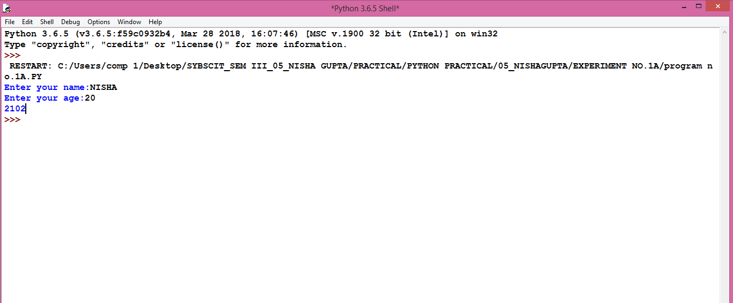

**CONCLUSION:PROGRAM WILL RUN.**